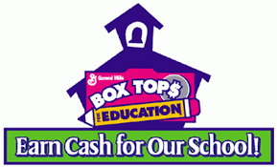

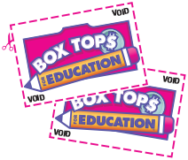

Collect **BOX TOPS** for Education.  
Ask your parents, family members, neighbors and friends to collect for you too!

The classroom that turns in the most

**BOX TOPS** by **February 23rd** will win

an **EXTRA RECESS !!!**